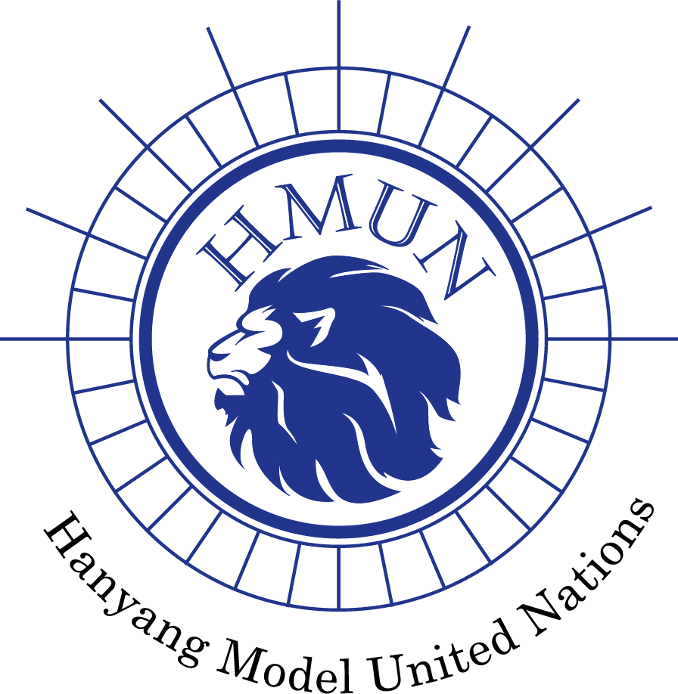
Hanyang Model United Nations VI Chair Report

Committee: United Nations Security Council (UNSC)
Chairs: Angelyn Nichole, Yoon Seo Choi
Agenda: Devising Measures to Improve the UN Peacekeeping Operation’s Feasibility in Order to Ensure the Delivery of Humanitarian Assistance

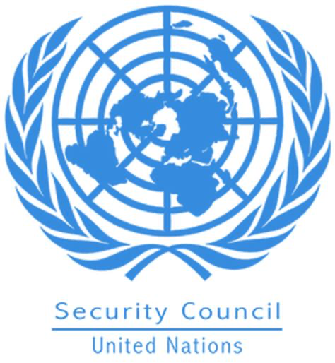
1. Committee Introduction
The United Nations Security Council was established after World War II, in accordance with the provisions of the UN Charter. It was founded in response to the horrors of war and the recognition of the need for a global collective body to prevent such devastating conflicts in the future. The United Nations Security Council (UNSC) succeeded the League of Nations, and its founding members sought to learn from the shortcomings of its predecessor.
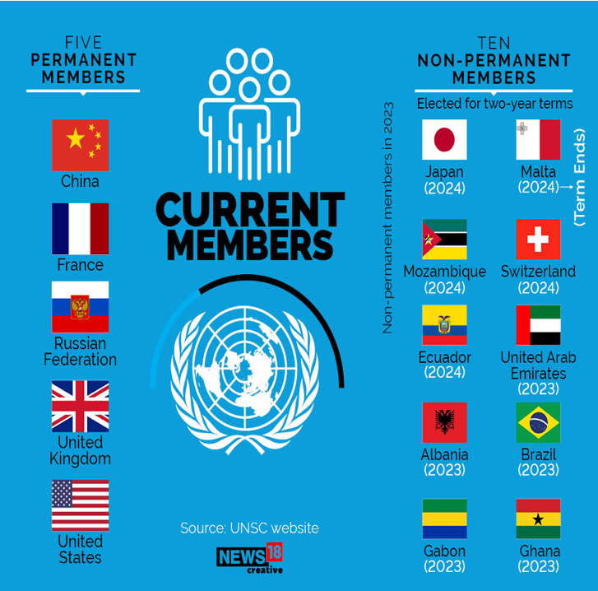
The UN Security Council has 15 members, five of which are permanent members, known as the P5 - China, France, Russian Federation, the United Kingdom, and the United States. These permanent members have veto power, allowing them to veto any substantive resolution, making Council dynamics complex and significant. The remaining ten seats are filled by rotating members elected for two-year terms from various regional groups. Currently, those seats are filled by Albania, Japan, Malta, Mozambique, Switzerland, Ecuador, United Arab Emirates, Brazil, Gabon, and Ghana (United Nations Security Council, n.d.).

The primary mission of the UN Security Council is to maintain international peace and security. It is given the authority to act on a wide range of issues, including the deployment of peacekeeping missions, the imposition of sanctions, and the authorization of military force to restore or enforce peace. The decisions of the UN Security Council are binding on all UN Member States, making it a powerful and unique international institution. According to the UN Charter, any state involved in a conflict, whether or not it is a member of the UN, may bring it to the attention of the Security Council. When a complaint is filed, the council's first step is to look into the possibility of a peaceful resolution. In some cases, the council may authorize the deployment of foreign peacekeeping forces to keep warring parties apart while further negotiations take place. If the council determines that there is a genuine threat to peace, a violation of the peace, or an act of aggression (as defined in UN Charter Article 39), it may request that UN members impose diplomatic or economic sanctions. If these measures are ineffective, the UN Charter authorizes the Security Council to take military action against the offending state (United Nations Security Council, n.d.).
The UN Security Council has played a critical role in addressing numerous global crises, conflicts, and humanitarian emergencies since its inception. The Council's agenda has evolved to meet the changing nature of global threats, from the Korean War in the early 1950s to more recent challenges in Syria, Ukraine, and climate change. To ensure that its responsibilities are met, the Security Council works with various committees. The Military Staff Committee, for example, aids in the coordination of military activity by UN members in accordance with council resolutions. There are also Sanctions Committees for each UN-sanctioned state, Peacekeeping Forces Committees in charge of overseeing UN peacekeeping forces, and an International Tribunals Committee that works to support the work of international criminal tribunals.

2. Agenda Background
a. Status Quo of UN’s Peacekeeping.
The United Nations has been and continues to be involved in several peacekeeping missions around the world. These operations were carried out in a variety of conflict scenarios and ranged in size and complexity. There are about 90,000 peacekeepers working for the United Nations in 12 operations across the world (United Nations Peacekeeping, n.d.). In terms of contributions accepted per mission, the United Nations Multidimensional Integrated Stabilization Mission in the Central African Republic (MINUSCA), which was established on April 10, 2014, has received the most. In accordance with Chapter VII of the UN Charter, the mission's goal is to safeguard people in the Central African Republic. Along with supporting the transition process, it also initially supported the promotion and protection of human rights, the rule of law and justice, as well as the processes of disarmament, demobilization, reintegration, and repatriation (MINUSCA, n.d.).
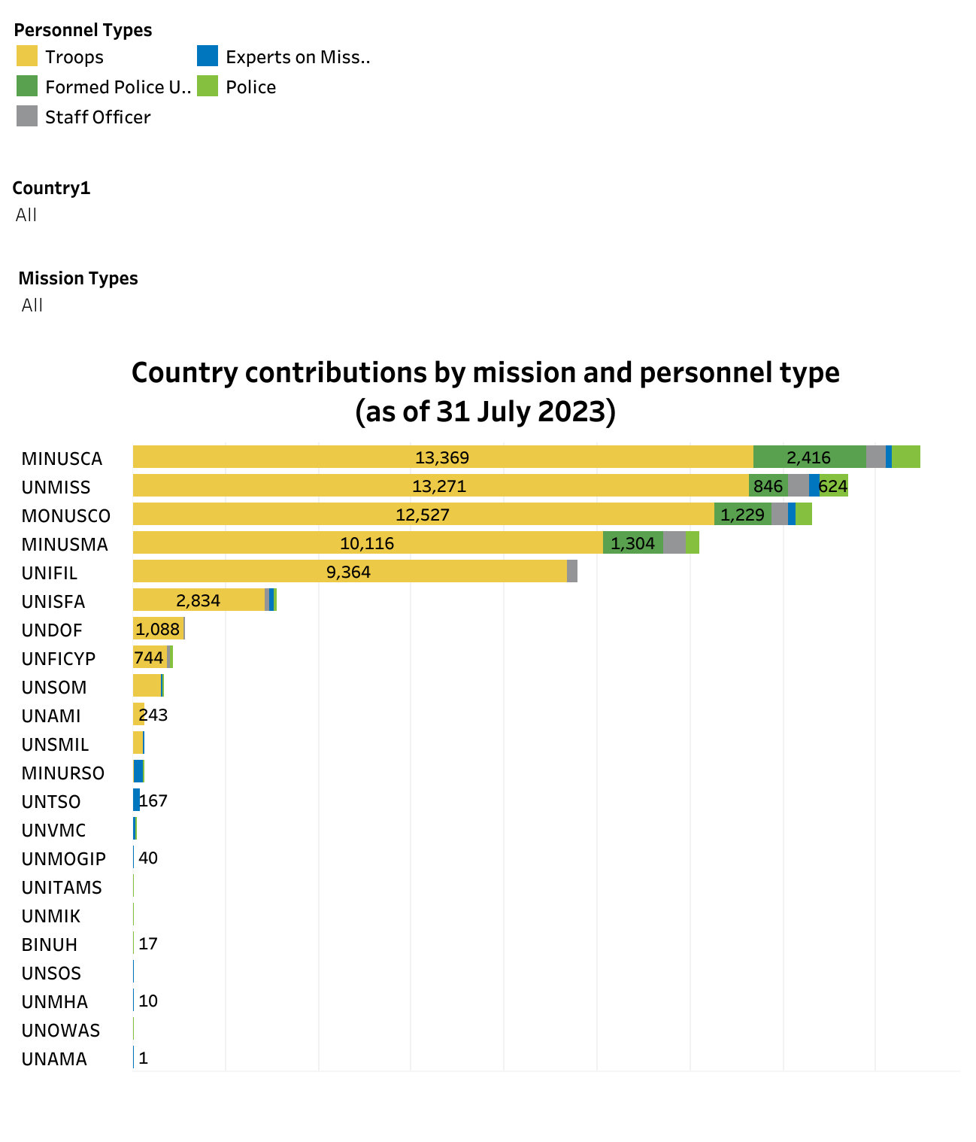
Fig. 1 Country Contributions by Mission and Personnel Type (as of 31 July 2023) (Source: Troop and Police Contributors United Nations Peacekeeping)

However, the current state of affairs in UN peacekeeping and humanitarian assistance demonstrates a critical need for improvement and increased contributions from other countries. When it comes to facilitating the delivery of humanitarian supplies in conflict zones, UN peacekeeping operations are frequently met with immense challenges. These difficulties vary from security and access constraints to resource constraints and the safety of UN personnel. The status quo is defined by a vital requirement to examine and improve the efficacy of peacekeeping missions in order to ensure that they can appropriately support and defend humanitarian aid delivery. Furthermore, today's conflicts provide new obstacles to peacekeepers. Many modern conflicts include non-state actors, asymmetric warfare, and complex political dynamics, making classic peacekeeping mandates increasingly difficult to carry out. Emerging dangers including cyberattacks and the deployment of unmanned aerial vehicles (drones) in war zones have presented new problems to peacekeepers. These difficulties necessitated the modification of peacekeeping methods and capabilities. These conflicts frequently coincide with humanitarian emergencies, necessitating the urgent delivery of help to vulnerable communities.
b. Lack of Funding, Contributions, and Resources
While the Security Council makes decisions on whether to initiate, sustain, or expand a peacekeeping mission, funding UN Peacekeeping operations is the collective duty of all UN Member States. Every Member State is legally required to contribute to peacekeeping. This is in compliance with the provisions of Article 17 of the United Nations Charter. The General Assembly allocates peacekeeping expenses based on a specific scale of assessments created by Member States themselves. This formula considers, among other things, the relative economic wealth of Member States, with the five permanent members of the Security Council obligated to pay a higher amount due to their specific responsibilities for international peacekeeping and security.

The budget for UN Peacekeeping activities for the fiscal year 1 July 2021 - 30 June 2022 has been authorized at $6.38 billion. This amount funds 10 of the 12 United Nations peacekeeping missions, including the UN-African Union Hybrid Operation in Darfur (UNAMID), supports logistics for the African Union Mission in Somalia (AMISOM), and provides support, technology, and logistics to all peace operations through global service centers in Brindisi (Italy) and a regional service center in Entebbe (Uganda). The UN regular budget funds the remaining two peacekeeping missions, the UN Truce Supervision Organization (UNTSO) and the UN Military Observer Group in India and Pakistan (UNMOGIP). The United States (27.89%), China (15.21%), Japan (8.56%), Germany (6.09%), United Kingdom (5.79%), France (5.61%), Italy (3.30%), Russian Federation (3.04%), Canada (2.73%), and the Republic of Korea (2.26%) are the top ten contributors to United Nations peacekeeping operations for 2020-2021. In comparison, the budget is less than 0.5 percent of global military spending (estimated at $1,981 billion in 2020). The budget for 2021-2022 is a 2.1% drop from the approved budget for 2020-2021 (How We Are Funded, n.d.).

Furthermore, the UN has no military forces of its own, and Member States contribute the military and police troops required for each peacekeeping mission on a voluntary basis. Peacekeeping soldiers are paid by their respective governments based on their national rank and salary system. As of 1 July 2019, countries donating uniformed personnel to peacekeeping operations are reimbursed by the UN at a standard rate established by the General Assembly of US$1,428 per soldier per month. The budgets for peacekeeping operations are used to pay police and other civilian employees. The UN also reimburses Member States for deploying military or police contingents with equipment, troops, and support services (United Nations Peacekeeping, n.d.).

However, numerous countries have yet to pay their dues, and the budget is simply insufficient to operate the missions, necessitating additional money from the UN. One significant example is the United States, which failed not pay in full, resulting in a $693 million shortfall in the UN budget. In 2019, the organization nearly ran out of finances due to non-payments from the United States and others (Buchholz, 2022). Countries withholding their dues for reasons such as dissatisfaction with UN decisions have put pressure on the organization to change its goals. Furthermore, whenever the UN need additional funding, if no formal system for generating funds exists, the UN must request it in order to meet the organization's goals. As such, the UN is continuously strapped for resources and its overall effectiveness remains compromised.

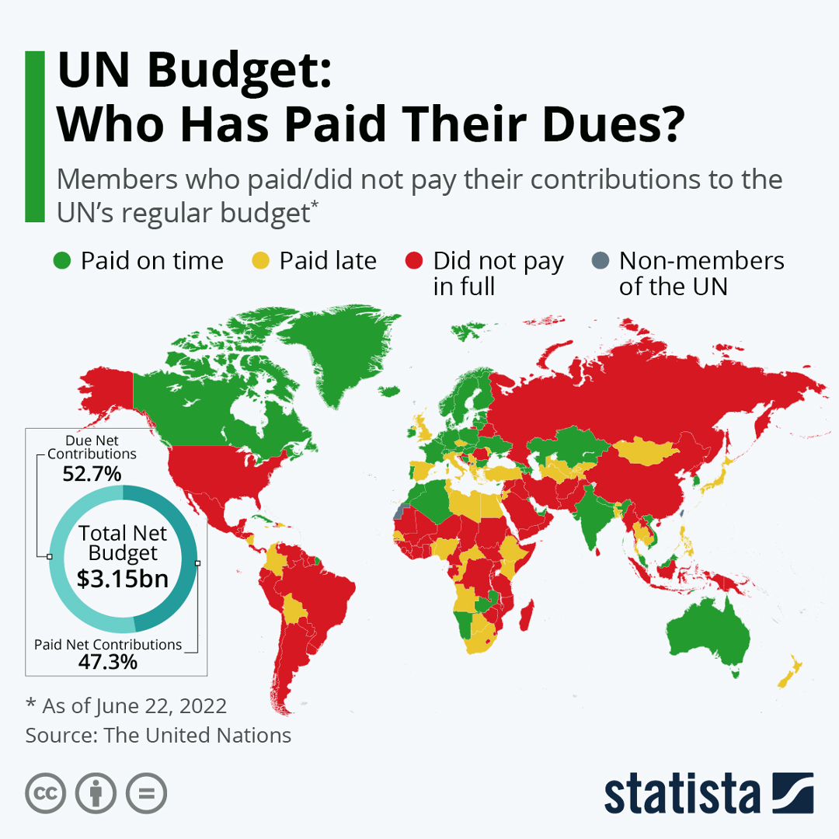
Fig. 2 UN Budget: Who Has Paid Their Dues? (Source: Statista)

c. Protection of UN’s personnel
Since the 1990s, UN personnel have been assaulted, kidnapped, and assassinated in hotspots. UN workers are still under risk while seeking to provide humanitarian and development assistance. One recent example is the missions in Mali and the Democratic Republic of the Congo. The United Nations Multidimensional Integrated Stabilization Mission in Mali (MINUSMA) was the deadliest for peacekeepers for the ninth year in a row, with 14 fatalities, followed by the United Nations Organization Stabilization Mission in the Democratic Republic of the Congo (MONUSCO), which had 13 fatalities. At least 32 UN peacekeeping personnel - 28 military and four police - were killed in 2022. This brings the total number of UN and associated personnel killed in deliberate attacks over the last 12 years to at least 494. These attacks included improvised explosive devices, rocket-propelled grenades, artillery fire, mortar rounds, landmines, armed and successive ambushes, convoy attacks, suicide attacks, and targeted assassinations. (At Least 32 Peacekeeping, Associated Personnel Killed in Malicious Attacks During 2022, United Nations Staff Union President Says | UN Press, 2023). These and other cases highlight the dangers and difficulties that UN staff encounter while working in conflict zones and humanitarian crises. The unwillingness of member states to contribute military resources to safeguard UN operations, as well as the current financing crises for humanitarian and peacekeeping initiatives, have intensified the risks faced by UN personnel. Security and safety of UN workers continue to be significant issues in efforts to deliver humanitarian and development assistance in such settings.

d. Limited Access
Access to conflict-affected communities is a recurring issue that impedes humanitarian relief delivery. In many conflict zones, parties restrict or block humanitarian agencies' access, delaying or stopping aid distribution to those in need. Yemen is a prime example of this. An estimated 21.6 million Yemenis would require humanitarian assistance in 2023, signalling an increasingly difficult working climate for relief organizations. Yemen's security situation is also incredibly tough for humanitarians. In 2022, humanitarian organizations recorded about 150 incidences of violence against their staff and facilities, the majority of which occurred in government-controlled areas. While the truce was in effect, tensions subsided and the civilian population experienced the longest period of calm in the conflict's eight years, prompting the Special Envoy to facilitate talks between the Houthis and the Yemeni government aimed at renewing the truce for another six months (Situation in Yemen Remains Stable, Special Envoy Tells Security Council, Highlighting Importance of Resuming Political Process, Ceasefire | UN Press, 2023). As a result, improving access for humanitarian personnel and aid convoys is critical to ensuring that aid reaches vulnerable populations in a timely and effective manner.

As things stand, several nations, including China, are eager to take the initiative in peacekeeping missions, demonstrating their dedication to international stability. However, there are significant challenges due to the restricted access to war areas. Despite its readiness to participate in additional missions and deployments, the entrance restrictions impede the provision of efficient humanitarian aid. This restriction needs strategic cooperation and diplomatic measures to increase access, enabling countries like China to successfully achieve their peacekeeping goals and assist global peace and security. In order for the UN's peacekeeping operations to function properly and deliver relief where it is most needed, it is imperative that these access limits be addressed.

3. Previous Actions
a. Mandate Renewals and Adaptations
The UN Security Council examines and renews the mandates of UN peacekeeping deployments on a regular basis, frequently altering them to improve the delivery of humanitarian aid. This involves broadening mandates to include civilian protection, improving humanitarian access, and tackling the core causes of war. The United Nations Multidimensional Integrated Stabilization Mission in Mali (MINUSMA) is a prime example of this. Recognizing the changing security and humanitarian situation in Mali, the UN Security Council frequently renewed MINUSMA's mandate. Provisions in the renewed mandates aimed at strengthening humanitarian access and support. Although some operations were hampered by Mali's junta's restrictions on air and ground movement, and access to conflict zones or sites of alleged rights violations was repeatedly delayed or denied, MINUSMA's sustained mandate renewals and adaptations had several notable effects. These effects included civilian protection, such as medical evacuations, and humanitarian assistance.
However, relations with Mali's leaders have deteriorated. The Mali government was outraged after a United Nations report in May accused the army and "armed white men" of killing 500 villagers in the town of Moura in 2022. Mali Foreign Minister Abdoulaye Diop requested MINUSMA to withdraw immediately on June 16, 2023. Prior to Diop's remarks, MINUSMA was anticipated to prolong its mandate for another year (Mcallister, 2023). As a result, MINUSMA will terminate operations on 30 June 2023, shifting its functions and withdrawing its personnel by 31 December 2023. Despite the fact that Mali's delegate continues to view the situation in his country as a threat to international peace and security at the Security Council meeting. Nonetheless, he added that his country's authorities have committed to working closely with MINUSMA to implement the resolution within the timeframe provided and to guaranteeing the safety and security of the Mission's personnel, facilities, and sites until its departure (Security Council Terminates Mandate of United Nations Multidimensional Integrated Stabilization Mission in Mali, Unanimously Adopting Resolution 2690 (2023) | UN Press, 2023).

b. Peacekeeping Force Augmentation
Peacekeeping force augmentation, which entails raising the size and capabilities of UN peacekeeping deployments, has been used in various conflicts to improve humanitarian relief delivery. When the UN Security Council recognizes the criticality of the humanitarian situation, it usually authorizes the addition of peacekeeping forces. This recognition emphasizes the urgent need for quick action to safeguard civilians and ensure the delivery of life-saving relief. The UN Security Council authorizes the expansion of peacekeeping personnel by a written decision. This decision specifies the particular aims, tasks, and length of the augmentation and may contain provisions for civilian protection, humanitarian assistance, and stabilization initiatives.
The United Nations-African Union Hybrid Operation in Darfur (UNAMID) is one example of this. It was a UN political mission to aid Sudan's transition. Following the High-Level Consultations in Addis Ababa, Ethiopia, on November 16, 2006, the UN Department of Peacekeeping Operations (DPKO) augmented the existing African Union Mission in Sudan (AMIS) and planned to deploy an unprecedented joint AU/UN peacekeeping mission in Darfur. Despite significant logistical and security challenges since it must operate in harsh terrain and in a complex and frequently hostile political context, it was able to finish its mandate on December 31, 2020 (About UNAMID, n.d.).

c. Engagement with Regional Organizations
Engagement with regional organizations is critical in tackling complex situations and improving humanitarian relief delivery. Regional institutions like the African Union (AU), the European Union (EU), and the Organization of American States (OAS) are well-positioned to respond to crises in their own regions. They are intimately familiar with the complexity and nuances of local disputes, historical grudges, and the social fabric of the communities they serve. This regional expertise, combined with their proximity and familiarity with the situation on the ground, enables them to act quickly and sensitively to cultural differences. Engagement with regional organizations has been increasingly institutionalized as a result of UNSC decisions and diplomatic initiatives, with particular mandates assigned to regional missions or cooperation frameworks.
The United Nations-Strengthened Engagement with the European Union in the Central African Republic (CAR) is one famous example of this. The Central African Republic's (CAR) difficulties are so complicated and intertwined that only a comprehensive approach focusing on security, humanitarian relief, stabilization, and development cooperation will make a difference. The EU is the country's principal development partner and humanitarian aid supplier. Since the beginning of the crisis in CAR in 2013, it has contributed more than €360 million in additional assistance. Over the years, the EU has also provided development aid to fulfil the most disadvantaged people's fundamental needs. Bêkou, the first EU Trust Fund, was formed in 2014 in collaboration with France, Germany, and the Netherlands to better support projects that combine humanitarian and development actions in CAR and pave the road for its recovery (The EU Engagement With the Central African Republic, 2015).

4. Possible Actions and Solutions
a. Safe Humanitarian Corridors
The United Nations Security Council (UNSC) has numerous options for establishing and maintaining safe humanitarian corridors to improve humanitarian relief delivery in war zones. These actions combine diplomatic, political, and operational tactics.
Accountability for violations of access agreements and humanitarian corridors is one approach to ensure their efficacy. The United Nations Security Council can create explicit reporting systems for violations of access agreements or occurrences that jeopardize humanitarian operations. It can also indicate the ramifications for parties who violate access agreements or hinder humanitarian corridors. Sanctions, international legal actions, or other measures determined by the UN Security Council may be imposed. All parties and individuals concerned should have access to these systems. Then, conduct comprehensive investigations and keep detailed records of any infractions. This includes gathering evidence, witness testimony, and incident recording in order to compile a full record of violations. The UN Security Council and the international community should use diplomatic pressure on warring parties to keep their pledges and honor access accords. Diplomatic sanctions or targeted engagement may be used.
Another important stage in building secure humanitarian corridors is to negotiate and implement humanitarian access agreements. Humanitarian access agreements are negotiated between humanitarian organizations and conflict parties such as governments and armed groups. These talks address critical topics such as access scope, routes, scheduling, and security guarantees. Access agreements must follow international humanitarian law, which includes principles like proportionality, distinction, and civilian protection. Parties to the conflict should pledge to uphold these ideals. The parties to the negotiations should agree to preserve humanitarian standards such as neutrality, impartiality, and independence. This ensures that aid is delivered on the basis of need and without bias. Monitoring and verification measures should be included in access agreements. Independent observers, international organizations, or UN agencies can monitor compliance with the agreements and report any violations or objections. This ensures the safety of peacekeepers and the effectiveness of humanitarian aid distribution.

b. Engagement with Non-State Actors
Finding successful channels of involvement is critical in the complex context of conflict zones, where non-state actors frequently wield enormous power and humanitarian aid is desperately needed. The United Nations Security Council (UNSC) faces the difficult task of navigating diplomatic channels to improve humanitarian relief delivery in these locations. Among the several techniques available, understanding the complexities of local dynamics is critical for successful humanitarian initiatives.
Local dynamics frequently revolve on complex power systems that may or may not be in accordance with international norms or formal governance. Recognizing local dynamics is a vital component of working with non-state actors to improve humanitarian aid delivery in crisis zones. Understanding the complexities of local power structures, societal norms, and community dynamics is critical in such contexts' complex and frequently changeable environments. Humanitarian groups and international organisations such as the United Nations Security Council (UNSC) can modify their tactics to better handle the obstacles and opportunities posed by non-state actors by identifying and respecting these localized variables. This sophisticated understanding not only develops trust and cooperation, but it also contributes to ensuring that humanitarian relief reaches those in need while eliminating potential hazards and hurdles. Recognizing local dynamics, in this context, provides as a foundation for successful diplomacy and talks, ultimately helping to the reduction of human suffering in conflict-affected areas.

c. Civil-Military Cooperation
Effective civil-military collaboration is critical for navigating the complex and demanding environments of conflict zones. It enables humanitarian organizations and armed units to collaborate more effectively, ensuring that relief reaches vulnerable populations while reducing hazards to humanitarian workers. The UN Security Council's endorsement and encouragement of such cooperation has the potential to dramatically improve the delivery of humanitarian relief in crisis situations. Civil-military liaison personnel, as well as integrated training and capacity building, are critical components of improving civil-military collaboration.
Civil-Military Liaison Officers (CMLOs) act as a critical link between humanitarian organizations and military troops operating in conflict zones. They facilitate the interchange of information, coordination, and collaboration between these two distinct entities, allowing them to work more successfully together. CMLOs are involved in conflict resolution and dispute resolution, dealing with difficulties that may occur between humanitarian actors and military troops. They aid in security coordination by ensuring that military units understand the security requirements of humanitarian operations and that humanitarian workers are aware of military security procedures. A CMLO must have certain qualifications, such as specialized training that provides them with the abilities required for civil-military liaison jobs, such as dispute resolution, negotiation, and cultural sensitivity. To acquire the faith of both civilian and military sides, they must maintain rigorous neutrality, impartiality, and independence. Cultural sensitivity and an awareness of local dynamics are also required, as they frequently work in varied and culturally complex situations.
The goal of integrated training programs is to promote mutual understanding and cooperation among humanitarian workers and military troops. They provide both groups with the information and skills necessary for effective collaboration in complicated, high-risk contexts. Training stresses adherence to humanitarian standards, ensuring that all players prioritize civilian and humanitarian worker protection. It also includes a grasp of the conflict's underlying origins, dynamics, and various participants' roles. Humanitarian workers learn about security standards and risk management, whereas military personnel learn about humanitarian ideals and the importance of safeguarding assistance activities. Joint exercises and simulations train participants to respond to disasters, such as the safe evacuation of humanitarian personnel in an emergency. Both humanitarian workers and military troops learn negotiating and conflict resolution skills that are useful in dealing with non-state actors and local populations.
In conclusion, Civil-Military Liaison Officers (CMLO) and integrated training and capacity building are critical in fostering effective civil-military collaboration. They allow humanitarian actors and military forces to coexist in crisis zones, ensuring that humanitarian aid is provided swiftly and safely while preserving humanitarian standards and civilian protection.

5. Defining of Key Words
a. Humanitarian Assistance
The provision of critical help, relief, and assistance to persons and communities affected by wars, disasters, or emergencies. This help includes food, clothing, and shelter.
b. Peacekeeping Operations
International forces, including military and civilian personnel, are deployed to war zones with the goal of maintaining or restoring peace, safeguarding civilians, and assisting in the delivery of humanitarian relief. Peacekeepers work under the authority of the United Nations and must follow the principles of impartiality, neutrality, and the use of force only in self-defense.
c. Security Council Mandate
The official authorization or instructions provided to a peacekeeping deployment or operation by the United Nations Security Council. The mandate defines the mission's objectives, scope of activities, and responsibilities, as well as measures for civilian protection and humanitarian aid facilitation.
d. Non-State Actors
Entities or groups that are not recognized states or governments yet have great influence and control over specific regions or territory. Non-state players in war zones may include rebel organizations, insurgents, militias, and other armed factions.
e. International Humanitarian Law
A system of legal concepts and regulations that govern the conduct of armed conflicts, sometimes known as the laws of war. It includes provisions for civilian protection, humanitarian workers, and humane treatment of prisoners of war.

6. Key Questions
I. How has the role of the UNSC evolved over the years in response to changing global threats and conflicts?
II. How do the dynamics of the UNSC, particularly the role of the permanent members and their veto power, impact the feasibility of UN peacekeeping operations?
III. What is the current state of funding for UN Peacekeeping operations, and how does it impact the effectiveness of these missions?
IV. What are the major risks and dangers that UN personnel face in conflict zones, and how do these challenges affect humanitarian efforts?
V. What actions and solutions can the UNSC consider to establish and maintain safe humanitarian corridors in conflict zones?
VI. How can the UNSC effectively engage with non-state actors to improve humanitarian aid delivery in complex conflict environments?
VII. What is the role of civil-military cooperation in enhancing the delivery of humanitarian relief in conflict zones, and what measures can be taken to promote effective collaboration between humanitarian organizations and military forces?
VIII. What are some potential actions and solutions that the UN Security Council can consider to establish and maintain safe humanitarian corridors for effective relief delivery in war zones?
7. Bibliography
About UNAMID. (n.d.). UNAMID. Retrieved September 23, 2023, from https://unamid.
unmissions.org/about-unamid-0.
At Least 32 Peacekeeping, Associated Personnel Killed in Malicious Attacks during 2022, United Nations Staff Union President Says | UN Press. (2023, January 20). United Nations Meetings Coverage and Press Releases. Retrieved September 22, 2023, from https://
press.un.org/en/2023/org1730.doc.htm.
Buchholz, K. (2022, June 24). UN Budget: Who Has Paid Their Dues? Statista Daily Data. https://www.statista.com/chart/15628/un-budget-who-has-paid-their-dues/#:~:text=In%
202019%2C%20non%2Dpayment%20from,also%20remain%20unpaid%20in%202022.
Mcallister, E. (2023, June 30). Explainer: Why Mali is kicking out U.N. peacekeepers. Reuters. http
s://www.reuters.com/world/africa/why-mali-is-kicking-out-un-peacekeepers-2023-06-30/.
MINUSCA. (n.d.). United Nations Peacekeeping. https://peacekeeping.un.org/en/mission/minusca.
Security Council Terminates Mandate of United Nations Multidimensional Integrated Stabilization Mission in Mali, Unanimously Adopting Resolution 2690 (2023) | UN Press. (2023, June 30). United Nations Meetings Coverage and Press Releases. Retrieved September 23, 2023, from https://press.un.org/en/2023/sc15341.doc.htm#:~:text=The%20Security%20
Council%20decided%20today,personnel%20by%2031%20December%202023.
Situation in Yemen Remains Stable, Special Envoy Tells Security Council, Highlighting Importance of Resuming Political Process, Ceasefire | UN Press. (2023, January 16). United Nations Meetings Coverage and Press Releases. Retrieved September 22, 2023, from https://
press.un.org/en/2023/sc15176.doc.htm.
The EU engagement with the Central African Republic. (2015, May 26). European Commission. Retrieved September 23, 2023, from https://ec.europa.eu/commission/presscorner/detail/
en/MEMO_15_5041.
United Nations Peacekeeping. (n.d.). How we are funded. Retrieved September 25, 2023, from https://peacekeeping.un.org/en/how-we-are-funded.
United Nations Peacekeeping. (n.d.). United Nations Peacekeeping. https://peacekeeping.un.org/en.
United Nations Security Council |. (n.d.). https://www.un.org/securitycouncil/.

